**Project Report**

**Submitted by:-**

Param Tank (195163693002)

Vishal Joshi (185160693011)

Bhargav Khamal (185160693012)

**Under Supervision of:-**

Prof. Pradeep Patel



**L. D. College of Engineering**

**Ahmedabad - 380015**

**Internal Guide:** **External Faculty:**

Prof. Pradeep Patel (Examiner)

Sign: ______________ Sign: ______________





**L. D. COLLEGE OF ENGINEERING**

**Ahmedabad-380 015**

**CERTIFICATE**

This is to certify that the project entitled **Software Project – 3(SP-III)** has been carried out by **Param Tank (195163693002), Vishal Joshi (185160693011) and Bhargav Khamal (185160693012)** under my guidance in fulfilment of the degree of **Master of Computer Application(MCA)** in **SEMESTER-**V of **Gujarat Technological University,** **Ahmedabad** during the academic year **2019**.

**Prof. Pradeep Patel**  Prof. **Shital**

(Internal Guide) (Head of the Department)

**Acknowledgment**

We are using this opportunity to express our gratitude to everyone who supported us through the course of this MCA project.

We are thankful for their aspiring guidance, invaluably constructive criticism and friendly advice during the project work.

We are sincerely grateful to them for sharing their truthful and illuminating views on a number of issues related to the project.

Last but not the least, a very special acknowledgment and warm regards to the mentor of this subject **Prof. Pradeep Patel** for her invaluable guidance during the course of this project work and helping us at each level of our project.

**Abstract**

The aim of this project is to develop a system that can offer movie advice to people looking for movies they like or looking for similar ones they love. In this document, we will present to you what is our project will be look like, what are the algorithms that we may use and which software we will use, systems uses these algorithms.

**Index**

|  |  |  |
| --- | --- | --- |
| Sr. No | Topic | Page Number |
|  | Introduction  1.1 Existing System  1.2 Need for the New System  1.3 Objective for the New System  1.4 Problem Definition  1.5 Core Components  1.6 Project Profile  1.7 Assumptions and Constraints  1.8 Advantages & Disadvantages of the Proposed System |  |
|  | Requirement Determination & Analysis   * 1. Requirement Determination   2. Targeted Users |  |
|  | System Design   * 1. Use Case Diagram   2. Class Diagram   3. Interaction Diagram   4. Activity Diagram   5. Data Dictionary |  |
|  | Development  4.1 Coding Standards |  |
|  | Agile Documentation   * 1. Agile Project Charter   2. Agile Roadmap/Schedule   3. Agile Project Plan   4. Agile User Story   5. Agile Release Plan   6. Agile Sprint Backlog   7. Agile Test Plan   8. Earned-value and burn charts |  |
|  | Proposed Enhancements |  |
|  | Conclusion |  |
|  | Bibliography |  |

1. **Introduction**

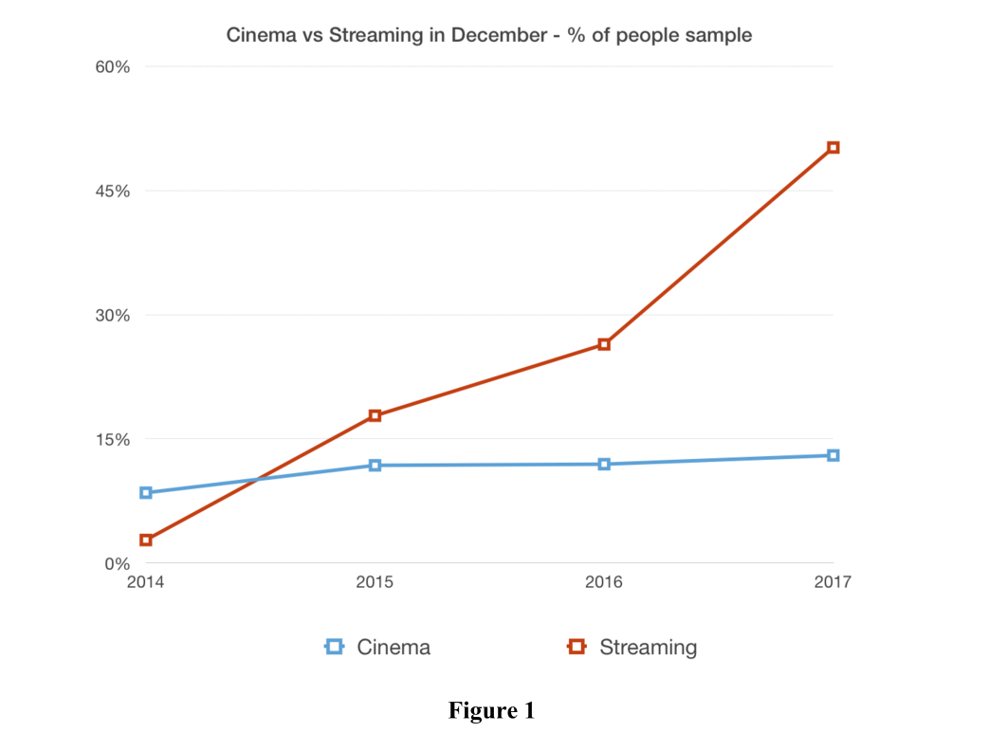 Over the past 5 years, watching movies and series on digital platforms is now a part of our lives. While the film industry is slowly losing its influence, watching movies on the Internet and paying less for it is becoming a better and easier method for everyone. With the increase in our internet speeds, we are now able to watch movies or series from various platforms very comfortably. Some companies that foreseen this development have increased their investments in this field and have become the pioneers of this sector. As we can see from the Figure 1, the internet movie watching sector has increased over the years and will continue to increase at the same speed.

* 1. **Existing System**

The existing Movie recommendation system is generally by using google or and any web page articles about Good movies. In particular, we’ve chosen to explore the movie niche as this is an area where our project can provide significant improvements compared to existing products and systems. Traditional movie websites (IMDB, AOL Movies) function by proving global user ratings on movies in their database. Movies are categorized by metadata such as genre, era, directors, and so on. Users can search for movies, browse lists and read reviews written by critics or other users

**1.2 Need for the New System**

* There is a need of a system were user can find movies according to their interest and not upon someone else’s movie taste.
* Watching bad recommended Movies can lead to waste of time and energy.

**1.3 Objective for the New System**

* Users can browse through thousands of movies from our pre-loaded dataset.
* Users can get all the important information about the movie which can help them decide whether to watch the movie or not.
  1. **Problem Definition**

People used to have a hard time finding a movie that suits them. Because until 10 years ago, how could we set up a fast algorithm when our computers were not running fast? Even though people found such algorithms, we couldn't implement them because our calculations powers were slow. With the development of technology, such algorithms that could work fast began to be developed. Even though we don't realize this, they offer something every day. The aim of this project is to propose movies using specific algorithms according to the movies people like. Recently, similar systems have been used by large companies such as Amazon, Netflix, and Spotify. Netflix uses a system similar to this, but only for movies on its own platform. IMBD also uses this system and they have large datasets of movies, users can find similar movies that they searched for. Our system will also include those approaches and benefit from those platforms to develop a unique movie recommendation system.

**1.5 Core Components**

There are several core components that has been used for developing the web application of NS Motor Club that includes:

Front End: - Python-Django Framework

Back End: - MySQL

Software Used: - Visual Studio Code, XAMPP









* 1. **Project Profile**

|  |
| --- |
| **Project Title :** Movie Recommendation System |
| **Company/Institute :** L.D College of Engineering |
| **Duration :** 4 month |
| **Front End :** Python 3.7.2 |
| **Back End :** SQLite 3 |
| **Operating System :** MicrosoftWindows10 |
| **Team Member :[3]** Param Tank (195163693002)  Vishal Joshi (185160693011)  Bhargav Khamal (185160693012) |
| **Project Guide :** Prof. Pradip Patel |
| **framework :** Django Web Framework(Version-3.2) |

**1.7 Assumptions & Constraints**

**Assumptions:**

* + As part of their efforts to ensure prompt and reliable service for users, We developers assume that it will optimize their Movie Selection Process.
  + The main focus is to provide the seamless and user-friendly experience of the new system that they won’t find any difficulty in accessing the services.
  + We also assume that every end-user will provide accurate details so that we could provide the best quality service by recommending the best possible according to the choice.

**Constraints:**

* Data Security.
* User Verification.
* The system requires an active Internet connection.

**1.8 Advantages & Limitations of Proposed System**

**Advantages:-**

* The system will be provided eith more relavant movie options than past.
* Users can use the system even if they are not registered. If the user is not registered to the system, he/she can only search for a movie that he/she wants to and browse among all movies but that is it.
* If the user registered to the system, he/she can rate(like) movies they want to and after the user likes at least 8 movies. The system recommends movies that are similar to those of previous rated movies.
* There is no registration or hidden charges for using our service yet now.
* To choose from there is wide range of Movies categories namely horror, darama, comedy, action and many more. Total of 17 categories.

**Limitations:-**

* System will provide inaccurate results if data is not entered properly.
* Sometimes user won’t be able to find Movies they are searching for as the data set used for recommendation is not up to date.

**Requirement Determination and Analysis**

**2.1 Requirement Determination**

Requirement determination (IRD) is frequently and convincingly presented as the most critical phase of information system.

* **Interviewing:** It is the primary phase of collecting information. No project can be conducted without interviewing.
* **Questionnaires:** We have gathered information from many people in a very short time with the help of questionnaires. To conduct an effective survey, the users were grouped differently.
* **Observation:** People are not always very reliable informants, even when they try to be reliable and tell what they think is the truth. However, observation can cause people to change their normal operation behaviour.
* **Analysing procedures and other documents:** By examining existing system and organizational documentation, we can find details such as problem with existing systems, opportunities to meet new needs, etc.
* **Joint Application Design (JAD):** The main idea behind JAD is to bring together the key people involved with the system.

**Prototyping:** It is a means of exploring ideas before you invest in them.

|  |  |  |  |  |  |  |
| --- | --- | --- | --- | --- | --- | --- |
| Characteristic | Interviews | Questionnaires | Observation | Document analysis | JAD | Prototyping |
| Information Richness | High | Medium to low | High | Low (passive) and old | High | Medium to High |
| Time Required | Can be extensive | Low to moderate | Can be extensive | Low to moderate | Dedicated period of time of all kinds of involved people | Moderate and can be extensive |
| Expense | Can be high | Moderate | Can be high | Low to moderate | High | High |
| Chance for Follow-up and probing | Good | Limited | Good | Limited | Good | Good |
| Confidentiality | Interviewee is known to interviewer | Respondent can be unknown | Observee is known to interviewer | Depends on nature of document | All the people know each other | Usually know each other |
| Involvement of Subject | Interviewee is involved and committed | Respondent is passive, no clear commitment | Interviewees may or may not be involved and committed depending on whether they know if they are being observed | None, no clear commitment | All kinds of people are involved and committed | Users are involved and committed |
| Potential Audience | Limited numbers, but complete responses from those interviewed | Can be quite large, but lack of response from some can bias results | Limited numbers and limited time of each | Potentially biased by which documents were kept or because document not created for this purpose | Potentially biased by the subordinator intentionally don’t want to directly point out his superior’s errors. | Limited numbers; it is difficult to diffuse or adapt to other potential users |

**2.2 Targeted Users**

Movie Recommendation System has been developed with the aim of targeting three major kind of users which consists of:

1. Unregistered User
2. Registered User
3. Admin
4. **Unregistered User:**

The Unregistered User can only search for a movie that he/she wants to and browse among all movies but that is it.

1. **Registered User:**

The Registered User can rate(like) movies they want to and after the user likes at least 8 movies. The system recommends movies that are similar to those of previous rated movies.

1. **Admin:**

The admin can manage the user and user likes. he/she can edit and also can delete the user or the user the user details.

**System Design**

**3.1 Use Case Diagram**

**User**:-

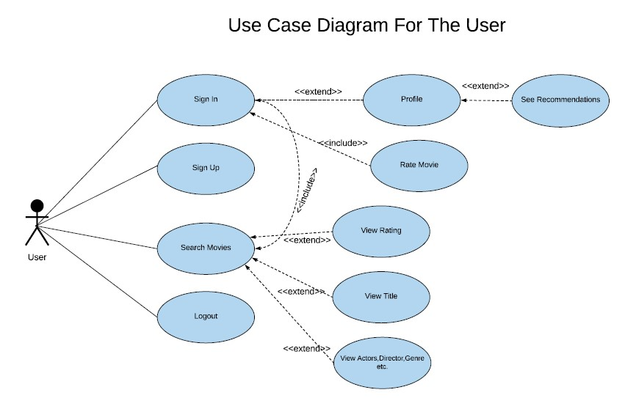

Registered User:-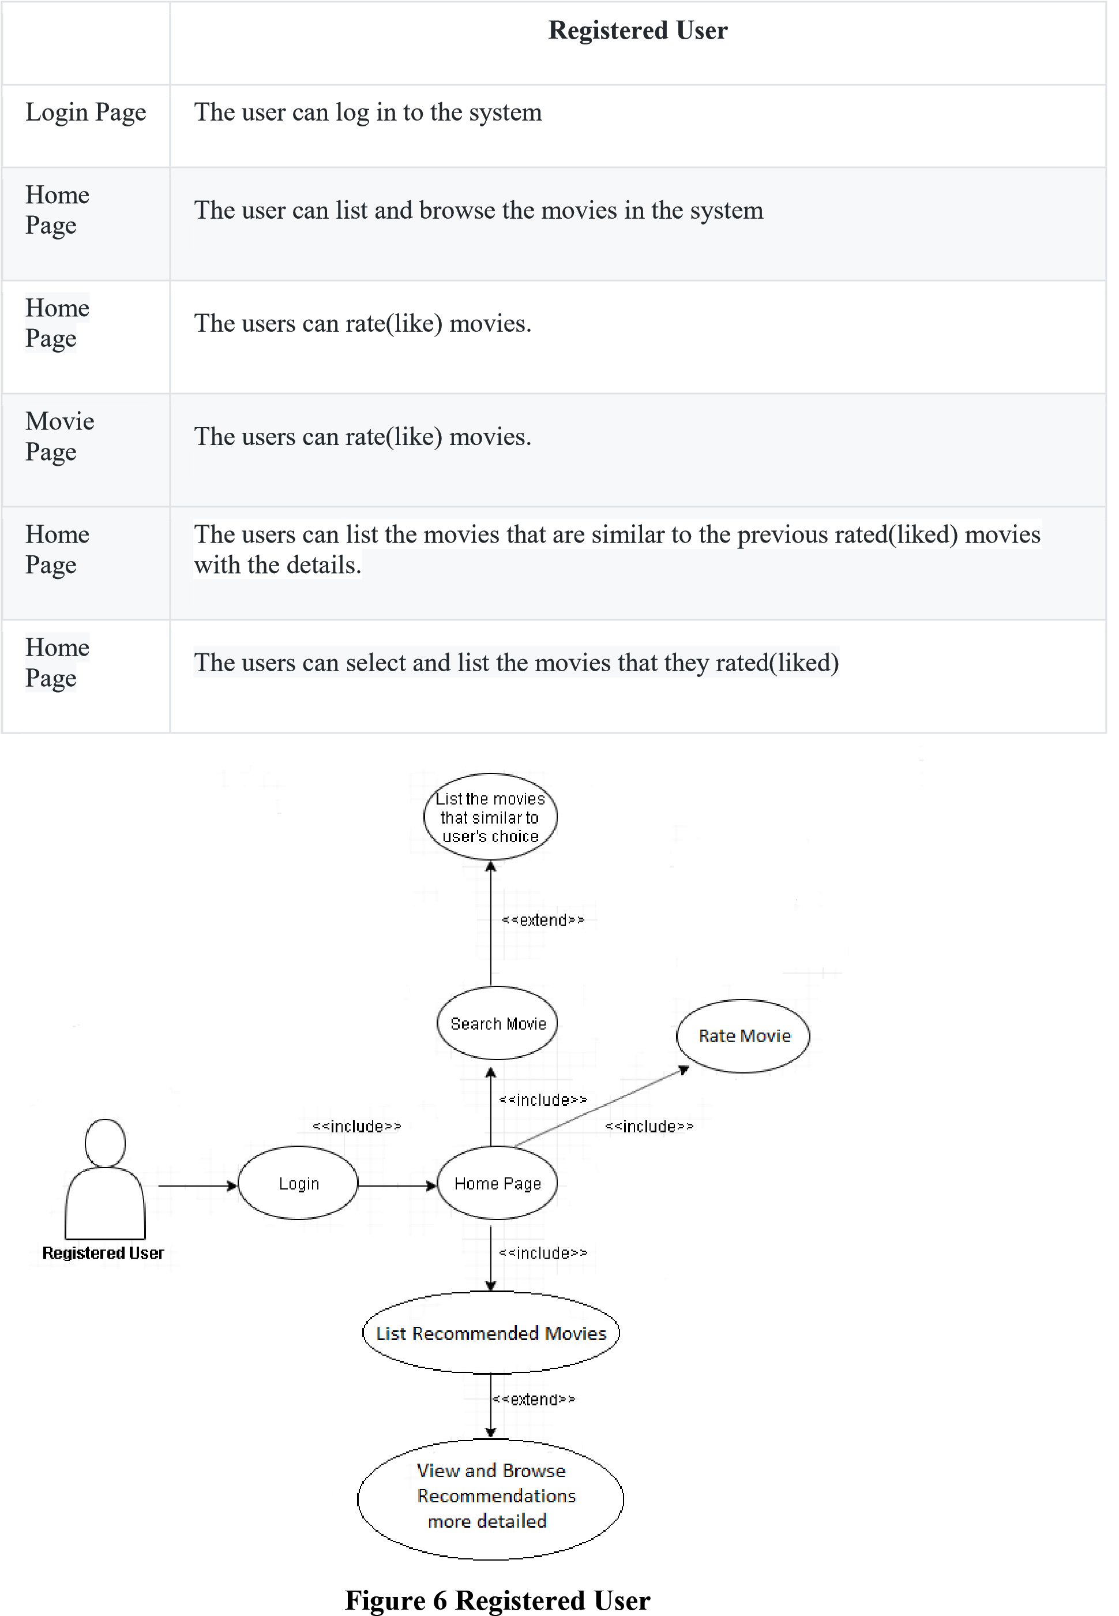

Unregistered User:-

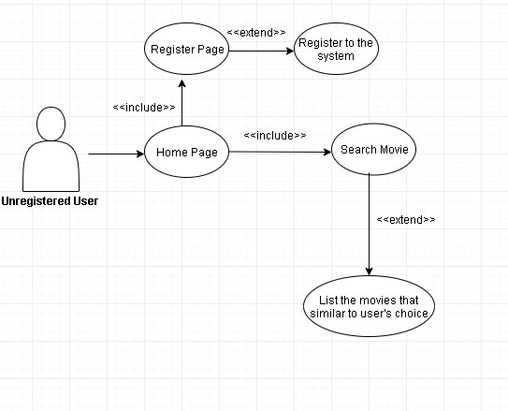

**Figure 7 Unregistered**

**User**

**3.2 Class Diagram**

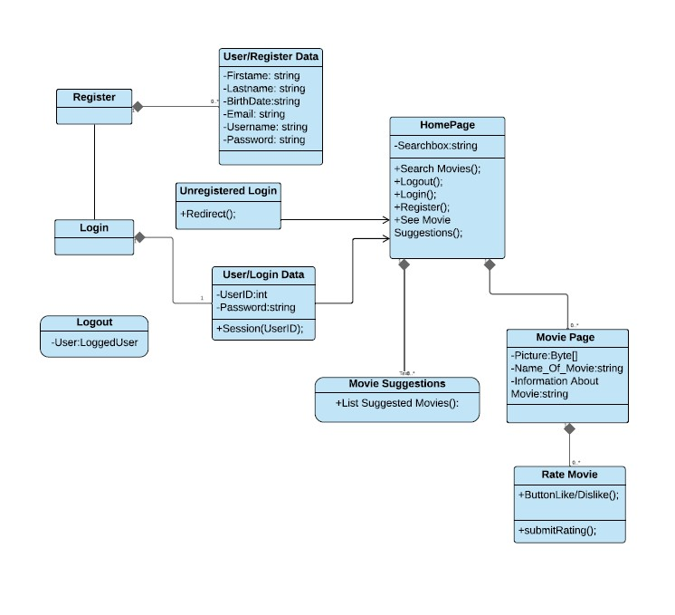

**3.5 Data Dictionary**

|  |  |
| --- | --- |
| **No.** | **List of tables** |
| 1 | Register |
| 2 | Company |
| 3 | Model |
| 4 | Car |
| 5 | Service |
| 6 | User-request |
| 7 | Merchant |
| 8 | Membership |
| 9 | Merchant-membership |
| 10 | Product |
| 11 | Product-Details |
| 12 | Cart |
| 13 | Checkout |
| 14 | Payment |

|  |  |  |  |  |
| --- | --- | --- | --- | --- |
| Field-Name | Data-Type | Size | Constraint | Description |
| Id | INT | 10 | Primary Key |  |
| Type | VARCHAR | 25 | Not Null |  |

**Table Name:- Product**

|  |  |  |  |  |
| --- | --- | --- | --- | --- |
| Field-Name | Data-Type | Size | Constraint | Description |
| ProductID | INT | 10 | Primary Key |  |
| Name | VARCHAR | 25 | Not Null |  |
| ProductImg1 | VARCHAR | 100 | Not Null |  |
| ProductImg2 | VARCHAR | 100 | Not Null |  |
| ProductImg3 | VARCHAR | 100 | Not Null |  |
| ProductImg4 | VARCHAR | 100 | Not Null |  |
| Price | BIGINT | 20 | Not Null |  |
| Old Price | BIGINT | 20 | Not Null |  |
| Description | VARCHAR | 500 | Not Null |  |
| Quantity | TINYINT | 10 | Not Null |  |
| Date | DATE/TIME |  | Not Null |  |
| Brand_Id | INTEGER | 10 | Foreign Key |  |
| SubCategory_ID | INTEGER | 10 | Foreign Key |  |
| Car_Model_Id | INTEGER | 10 | Foreign Key |  |

**Table Name:- Review**

|  |  |  |  |  |
| --- | --- | --- | --- | --- |
| Field-Name | Data-Type | Size | Constraint | Description |
| ReviewID | INT | 10 | Primary Key |  |
| Review | VARCHAR | 100 | Not Null |  |
| Rating | BIGINT | 20 | Not Null |  |
| Product_Id | INTEGER | 10 | Foreign Key |  |
| RegiID | INTEGER | 10 | Foreign Key |  |

**Table Name:- Service**

|  |  |  |  |  |
| --- | --- | --- | --- | --- |
| Field-Name | Data-Type | Size | Constraint | Description |
| ServiceID | INT | 10 | Primary Key |  |
| Service_Name | VARCHAR | 25 | Not Null |  |

**Table Name:- Package_Type**

|  |  |  |  |  |
| --- | --- | --- | --- | --- |
| Field-Name | Data-Type | Size | Constraint | Description |
| Id | INT | 10 | Primary Key |  |
| Type | VARCHAR | 25 | Not Null |  |

**Table Name:- Sub_Category**

|  |  |  |  |  |
| --- | --- | --- | --- | --- |
| Field-Name | Data-Type | Size | Constraint | Description |
| SubCategoryID | INT | 10 | Primary Key |  |
| SubCategoryName | VARCHAR | 25 | Not Null |  |
| Category_Id | INTEGER | 10 | Foreign Key |  |

**Table Name:- User_Request**

|  |  |  |  |  |
| --- | --- | --- | --- | --- |
| Field-Name | Data-Type | Size | Constraint | Description |
| RequestID | INT | 10 | Primary Key |  |
| Location | VARCHAR | 25 | Not Null |  |
| Regi_ID | INTEGER | 10 | Foreign Key |  |
| Service_ID | INTEGER | 10 | Foreign Key |  |

**Table Name:- User_Address**

|  |  |  |  |  |
| --- | --- | --- | --- | --- |
| Field-Name | Data-Type | Size | Constraint | Description |
| Id | INT | 10 | Primary Key |  |
| Address | VARCHAR | 100 | Not Null |  |
| Landmark | VARCHAR | 25 | Not Null |  |
| Pincode | BIGINT | 10 | Not Null |  |
| Regi_ID | INTEGER | 10 | Foreign Key |  |
| City_Id | INTEGER | 10 | Foreign Key |  |
| State_Id | INTEGER | 10 | Foreign Key |  |

**Development**

**4.1 Coding Standards**

**1.** **App Structure**:-

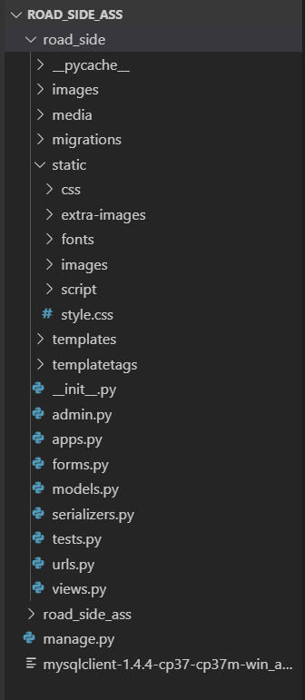

**2. Python Coding Style:-**

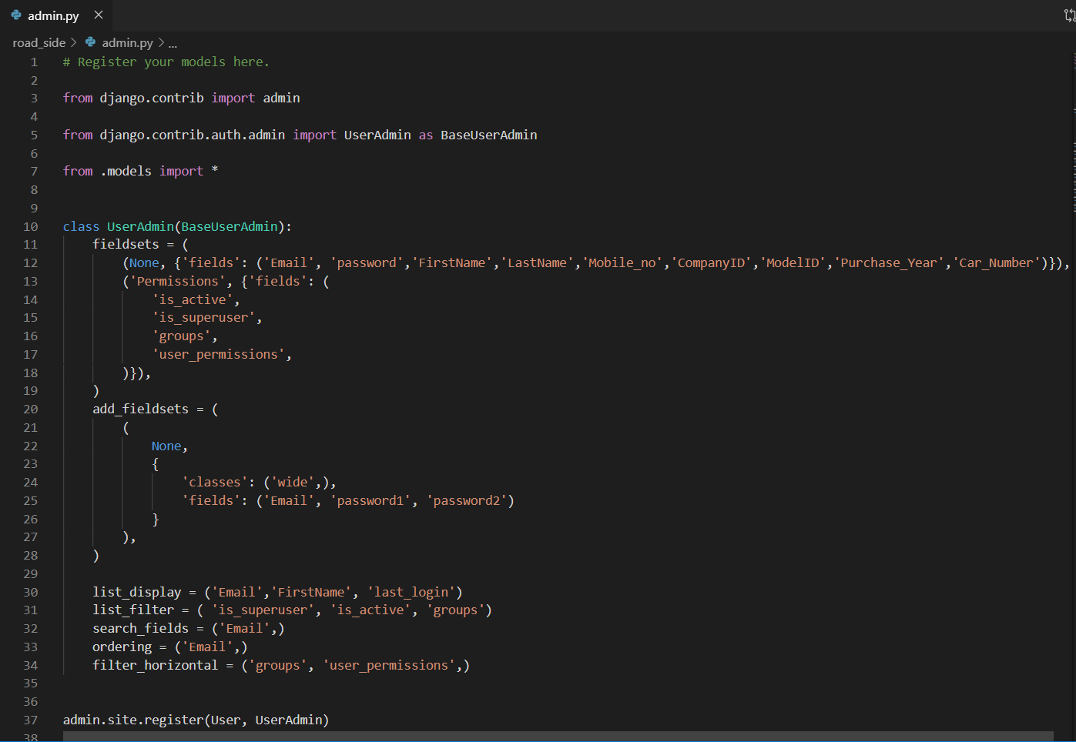

**3. Template Style:-**

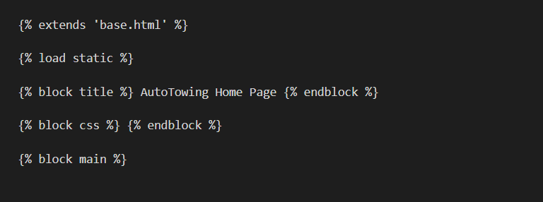

**4. View Style:-**

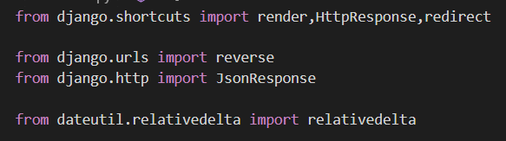

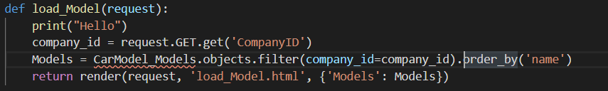

**5. Model Style:-**

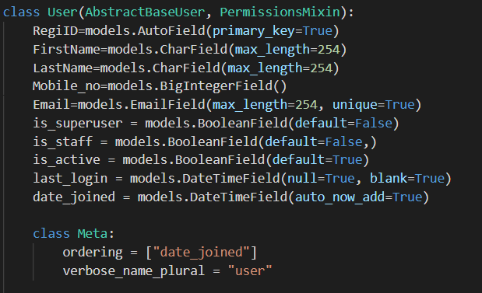

**6. Django Configuration:-**

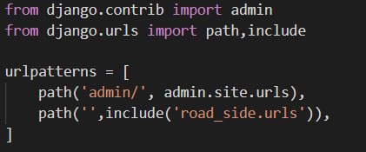

**Agile Documentation**

**5.1 Agile Project Charter:**

|  |  |
| --- | --- |
| 1. **SUMMARY** | |
| **Project Name** | **NS Motor Club** |
| **Executive Sponsor** | **L. D. College of Engineering** |
| **Project Manager or Lead or Member** | **Sumeet Tilokani, Nisarg Sheth, Sonu Prajapati** |
| **Project Start – End Dates** | **25/6/2019 – 10/10/2019** |
| **Project Purpose** | **The main objective of NS Motor Club is to provide emergency road side assistance services round the clock to ensure a pleasurable and uninterrupted journey virtually anywhere.** |
| **Budget /Resources** | **3 developers** |
| **Approved Date** | **01/07/2019** |

|  |
| --- |
| 1. **SCOPE** |
| **Purpose:** *The application is designed to enhance the user experience and ensure that users get immediate and hassle free service in the event of any vehicle breakdown.*  **Background:** *Our team shall make all possible efforts to locate and direct the nearest service provider to user’s location.*  **Inclusion/ Exclusion Criteria (mandatory):**  ***Inclusion***   * *In our website we are allowing user to upload photos, videos and description.* * *We show them suggested post for them.* * *We allow user to manage their profile.* * *We allow user to chat with each other.* * *We are allowing user to like and comment on post.*   ***Exclusion***   * *We do not allow user to share inappropriate post which is part of our terms and condition.* |
| 1. **BENEFITS** |
| * **People will get a platform where they can share their talent and get valuable feedbacks or help.** * **If they find some talent or skill of others valuable for them, they can connect with each other using chat feature.** * **People will get suggested post on bases of their like history.** * **People will be able to connect each other for item purchase or small event management or stuff.** |

|  |  |  |  |
| --- | --- | --- | --- |
| 1. **POTENTIAL ISSUES & RISKS** | | | |
| **Issue / Risk** | **Description** | **Probability**  **(H, M, L)** | **Impact**  **(H, M, L)** |
| Inappropriate post | Image processing is in our future enhancement, if someone posts inappropriate post we have to wait someone to report that post so admin can take actions. | L | H |
| Fake post | People can share fake post to misguide people. | H | L |
| Scam | If people are connecting for deal or something there is probability of scam. We can warn people to be aware of scams but we cannot control it. | L | H |

|  |
| --- |
| 1. **PROJECT BUDGET/ RESOURCES** |
| * Three members are involved in this project for the work of designing, developing, testing and data handling process. |

|  |  |  |
| --- | --- | --- |
| 1. **PROJECT TEAM** | | |
| **Role** | **Name** | **Business Area** |
| Internal Guide | Bhavesh Oza | Professor |
| Member | Sumeet Tilokani | Designer/Developer |
| Member | Nisarg Sheth | Project Testing/Data Handling |
| Member | Sonu Prajapati | Designer/Developer |

|  |  |  |
| --- | --- | --- |
| 1. **AUTHORIZATION** | | |
| Approved by Internal Guide: |  | Date: 01/07/2019 |
| Approved by Institute: |  | Date: 01/07/2019 |

**5.2 Agile Roadmap/Schedule**

**5.3 Agile Project Plan**

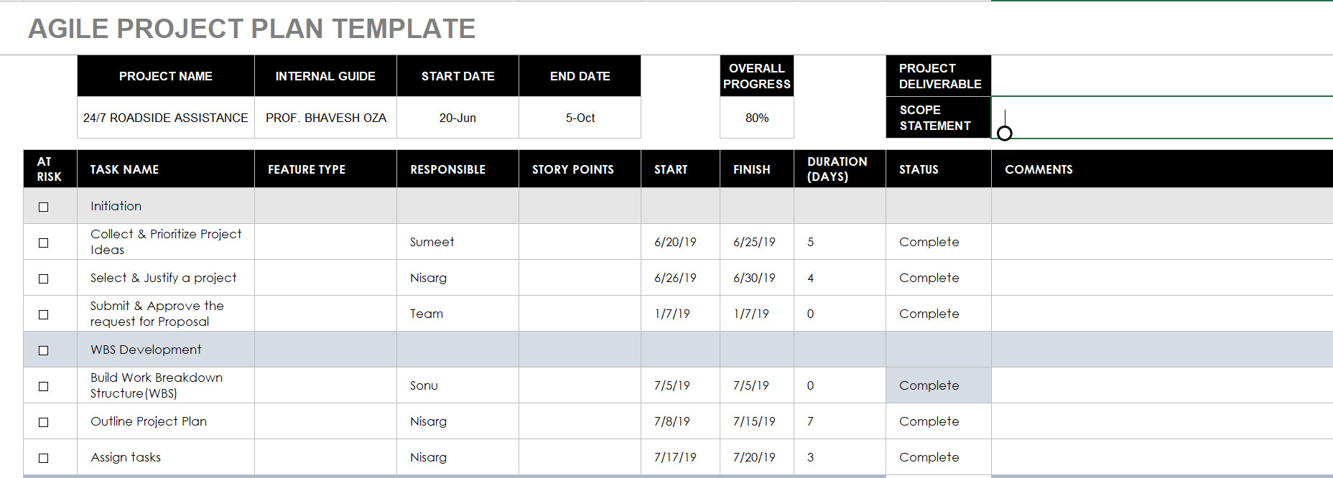

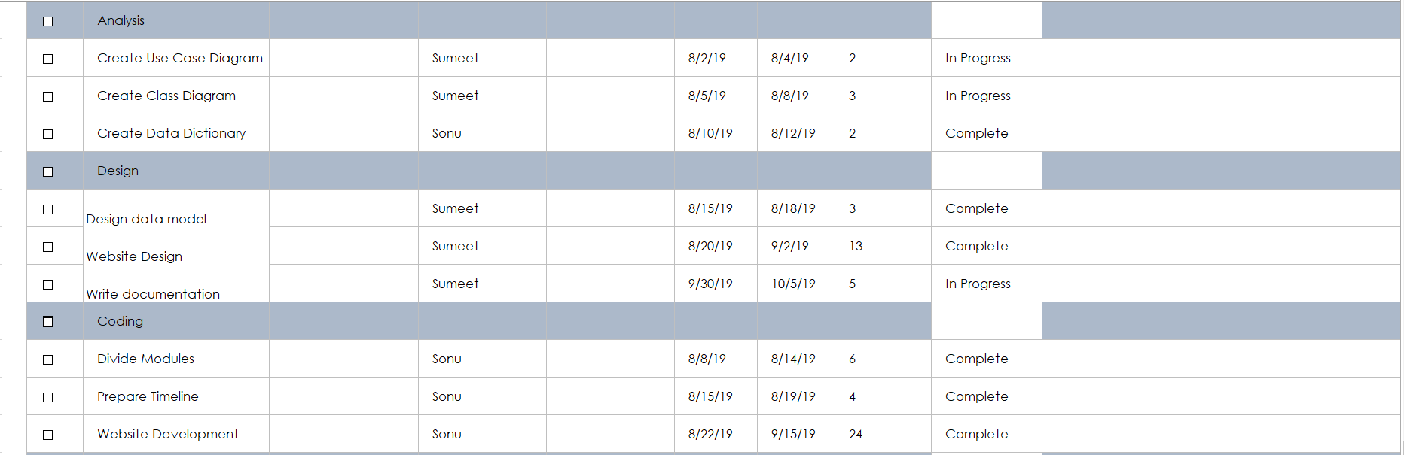

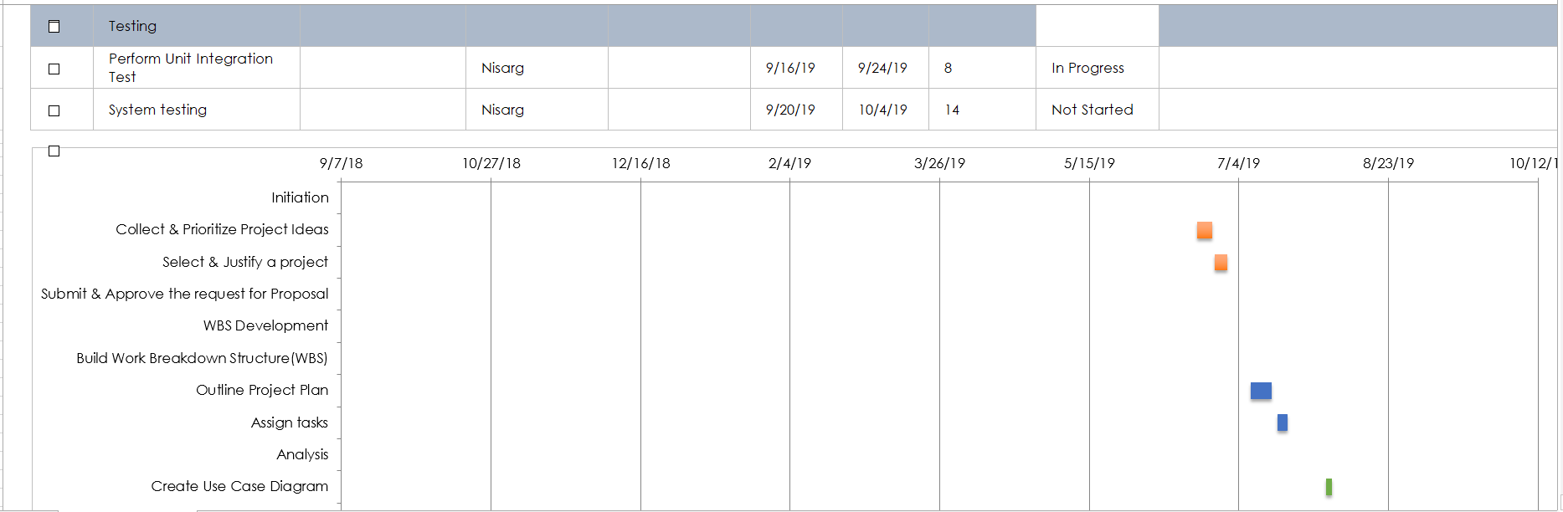

**5.4 Agile User Story**

**5.5 Agile Release Plan**

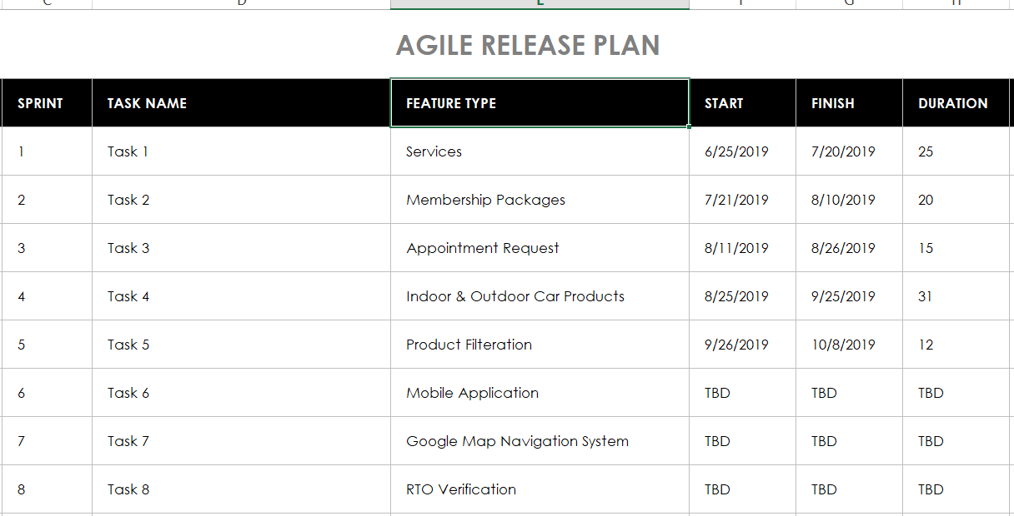

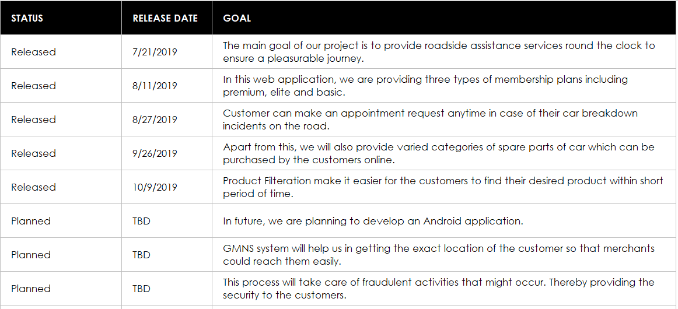

**5.6 Agile Sprint Backlog**

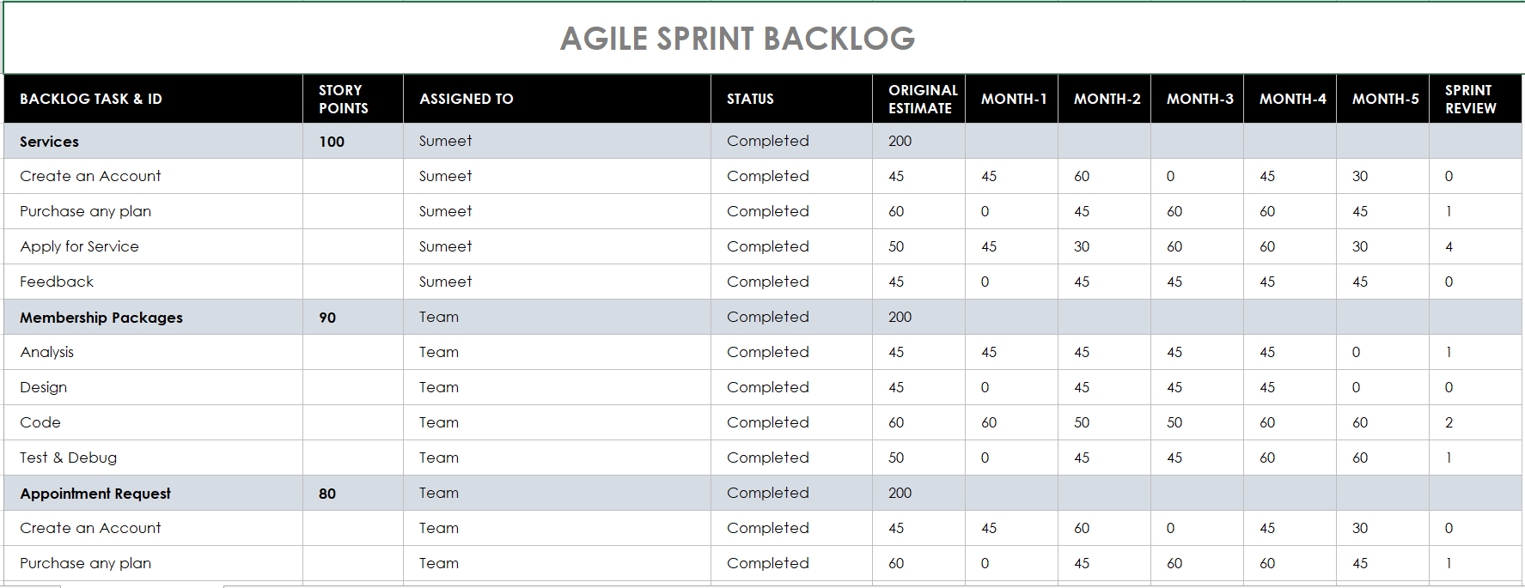

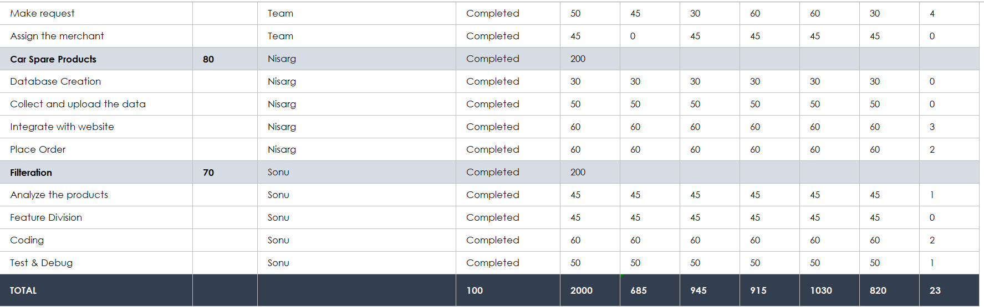

**5.7 Agile Test Plan**

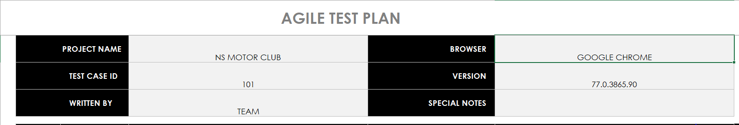

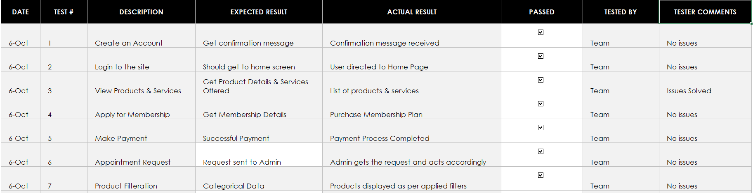

**5.8 Earned Value and Burned Chart**

**Proposed Enhancements**

Movie Recommendation System can be added with more enhanced features like

* If the movies recommended to a friend are the same as those proposed to you, your friend's movie taste may be similar to you. The system can show you the movies your friend watched.
* Add Movie Reviews to help users get better experience.
* The current system is designed and developed in Python using Django Framework which can also be done in several other technologies like Android and IOS. This will make more reach to large number of users. Also we are planning to develop an Android app of this system which will soon be available on the Google Play Store.
* System will ask for mood to have sentiment analysis and then recommend movies.

**Conclusion**

Even though we could not complete everything we wanted to do at the end of our project, we have completed the vast majority. We had to remove some features unfortunately. Our system runs well most of the time and we successfully implemented the cosine-based similarity method in our project. Users can easily register to the system and receive mostly accurate recommendations based on the movies they rated(liked) and easily browse, search and get more specific information among thousands of movies.(Movie overview, genre, runtime, score of the movie etc.)This project improved our both object oriented programming skills and how machine learning, prediction algorithm methods work.

**Bibliography**

**Follow the links**:-

1. <https://www.djangoproject.com/>
2. <https://realpython.com/django-setup/>
3. <https://www.stackoverflow.com/>
4. <https://code.visualstudio.com/docs/python/tutorial-django>
5. <https://www.tutorialspoint.com/django>
6. <https://www.smartsheet.com/>

**Books**:-

* Django for Beginners: Build websites with Python and Django – by William S. Vincent
* Django 2 by Example – by Antonio Mele
* Lightweight Django **-** by Elman and Mark Lavin
* Beginning Django: Web Application Development and Deployment with Python